Lab SO5.A
Unreal and Airsim Setup for Airsim and Splunk Integration
1. Prerequisites 1
1.1. Required Resources 1
2. Introduction 1
2.1. Lab Description 1
2.2 Initial Setup 2
3. Tasks 2
3.1 Task 1: Epic Games Launcher and Account Setup 2
3.2 Task 2: Unreal Engine Setup 4
3.3 Task 3: Airsim Setup 8
4. Submission details 15
5. Conclusion 16

Prerequisites

1.1. Required Resources

- Complete Lab S00
- Windows device preferably
  - Shouldn’t require Windows though

Introduction

2.1. Lab Description

Unreal Engine is a game development engine that was created in 1998 for the game “Unreal”, hence the name. It has become one of, if not the most, widely used game engines ever. It is owned by Epic Games, most famously known for the popular videogame “Fortnite” as I no doubt imagine you know. Recently, Unreal Engine has been utilized for other forms of media such as movies and TV due to its impressive libraries and usage guidelines. In our case, we will be using it to run our Airsim environment.

Airsim is a virtual training environment that was made by Windows in 2017 to test AI research for autonomous vehicles. It has both car and drone capabilities, but we are only interested in the drone aspects of the environment. It has a variety of functionality, from LiDAR and camera technology to realistic physics and data flexibility. In our case, we are going to be using this environment to accurately simulate real-life drone behavior and capture real-time packets to store in Splunk.

2.2 Initial Setup

Before we begin the lab, you need to be logged into your device, connected to the internet, able to use a search engine, and have a storage device that can hold all of the required materials. The storage requirements should not be anything more than 25 GB, with the majority going towards our Unreal Engine installation.

Tasks

3.1 Task 1: Epic Games Launcher and Account Setup

To run the simulation, we will first need to install Unreal Engine. Navigate to this page to install the Epic Games Launcher, which will allow us to install Unreal Engine.



Click the “Install on Windows” button, which will download an .msi file to your device. This will allow you to configure where you install the Epic Games Launcher. For this lab, it should not matter where you install this so long as you have space to install Unreal Engine.

Once you have installed the Epic Games Launcher, please make an Epic Games account. If you already have an account, you can use that to log in. You need an account to be able to download Unreal Engine, but we will not be using anything else within the launcher.

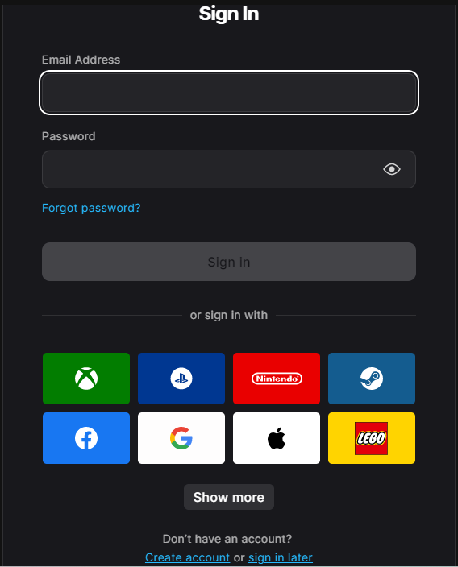

3.2 Task 2: Unreal Engine Setup

Once you have logged into your Epic Games account, navigate to the “Unreal Engine” tab on the top-left of the launcher.

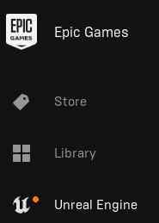

Once you click this menu, you should see a screen that looks similar to this.

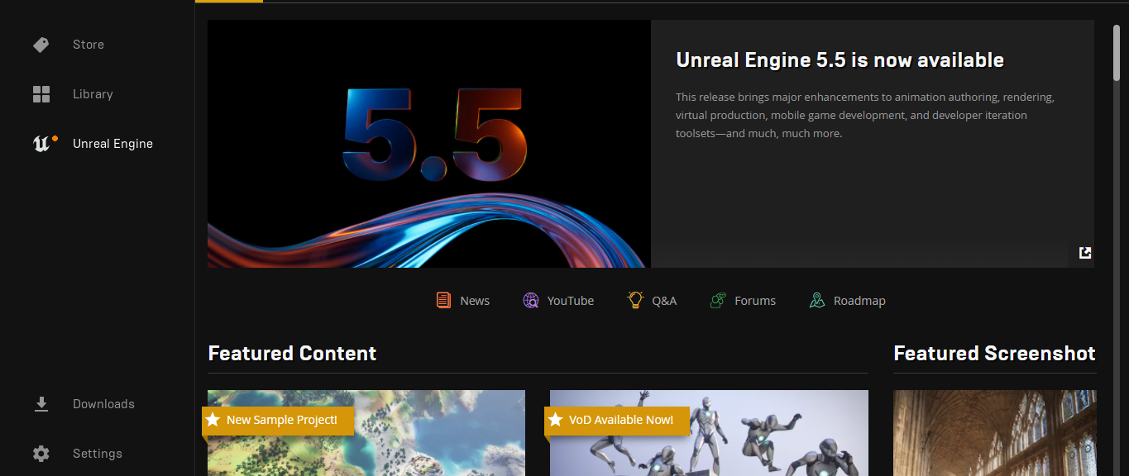

Now we need to install Unreal Engine, specifically version 4.27.2. To do this, click “Library” along the top.



This is where your Unreal Engine versions will be found. Currently, there should be an option that allows you to download the latest version of Unreal Engine. We do NOT want to do this, so instead we want to change the version we install. To do this, click the carrot to make a dropdown menu.

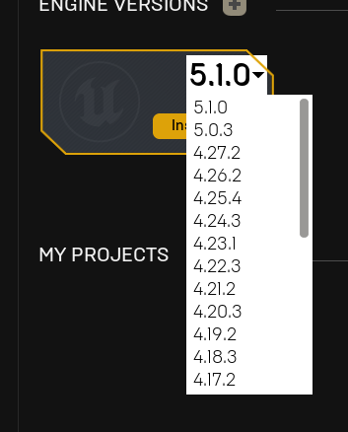

In your list, there should be an option numbered “4.27.2”. This is the version we want, so select it. Once you have it selected, click the orange “Install” button.

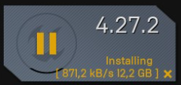

This will start the downloading and installing of Unreal Engine version 4.27.2, which you can track in the “Downloads” tab in the bottom left. This may take a very long time, so please be patient and check in on it to ensure no errors occur.



Once Unreal Engine 4.27.2 installs successfully, you should see a menu in your “Library” Tab under “Unreal Engine” that looks like this.

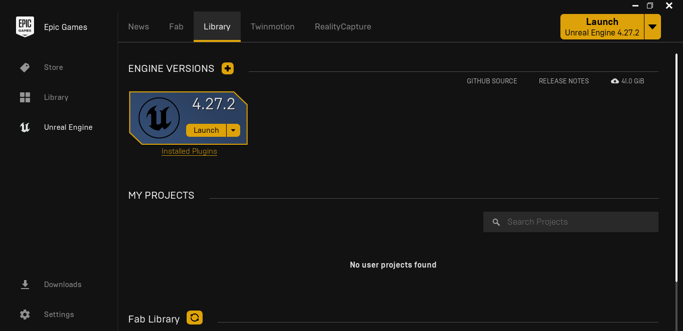

If this is what you see, then you have successfully installed Unreal Engine version 4.27.2 and can move on to setting up Airsim.

3.3 Task 3: Airsim Setup

Before we can get going, we will need to set everything up. First, navigate to this GitHub page so that we can begin setting up the AirSim environment.

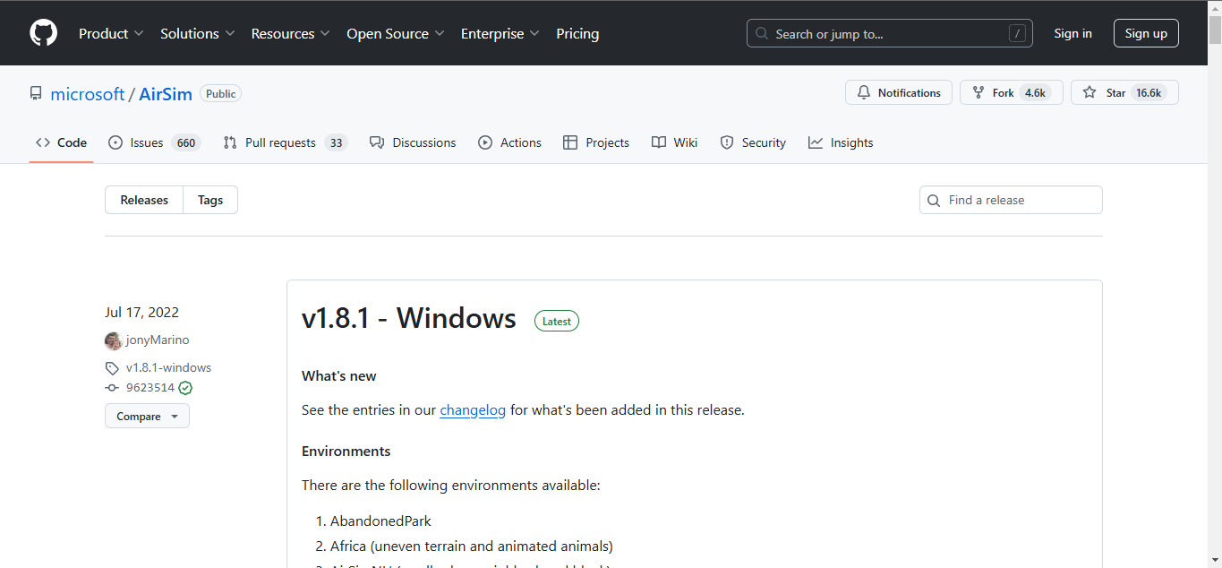

You will be looking for two files named “CityEnviron.zip.001” and “CityEnviron.zip.002”, as linked here. It is important to note that this is specifically the Windows versions, so if you are on Linux you will have to go (insert where Linux users go for equivalent files).

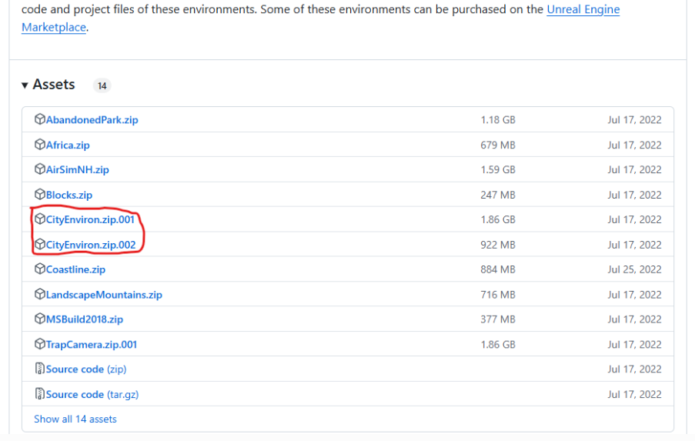

Please install each file one at a time. During testing, we found that installing both files at the same time may cause errors and generally makes the downloads slower than if you do it individually.

Once you have both files installed, you will need to use 7Zip to combine them. Currently, these two files are two halves of a whole that need to be combined before they are usable.

If you do not already have 7Zip, go to this page and install whichever version for your operating system. If you are on Windows, I would recommend the 64-bit Windows x64 one, which is right at the top of the page.

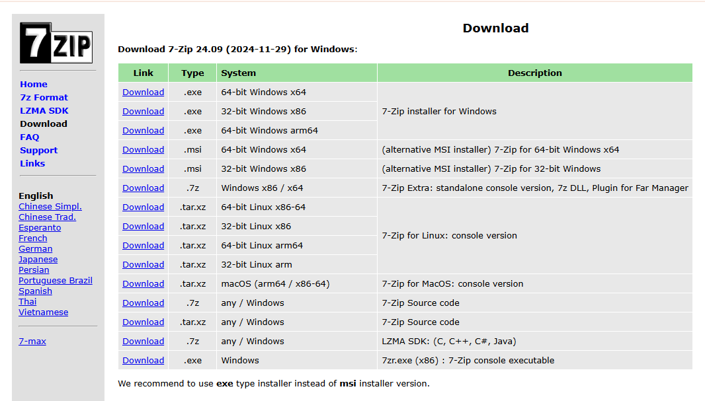

This will download an .msi file which will allow you to set up 7Zip. Once you have 7Zip installed and set up, you can combine the two CityEnvironment files.

To combine the two CityEnvironment files, first highlight both of them and right-click. This should pop up a menu with a variety of options. You want to select “Show More Options” at the bottom.

Once you have clicked “Show More Options”, you should get a screen that looks similar to this.

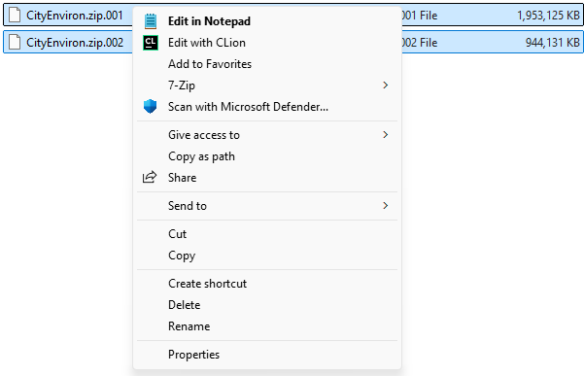

You should see a “7-Zip” option towards the top. If you do not, please reinstall 7Zip and try these steps again. If you do, then move to the right to expand your options and select “Extract Files” at the top of the list.

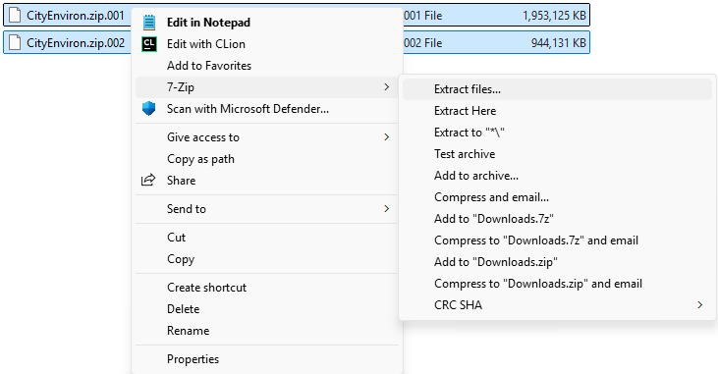

This should pop up a menu called “Extract” run by 7Zip which asks you for some information. You do not need to change any of the information here unless you want to change the directory you want the files extracted to, which you can also do later if you choose. Please press “OK” at the bottom of the menu to start the extraction process.

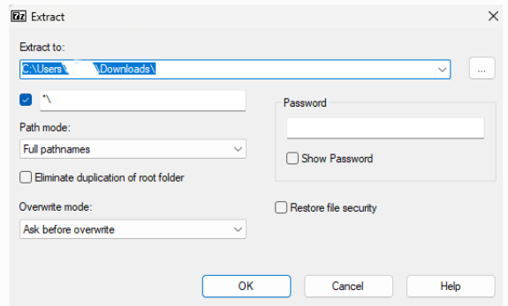

You should see a new menu pop up that details what is going on during the extraction process, but the only relevant information is that the files are being extracted properly. This should not take very long to extract, but you can track the progress if you would like.

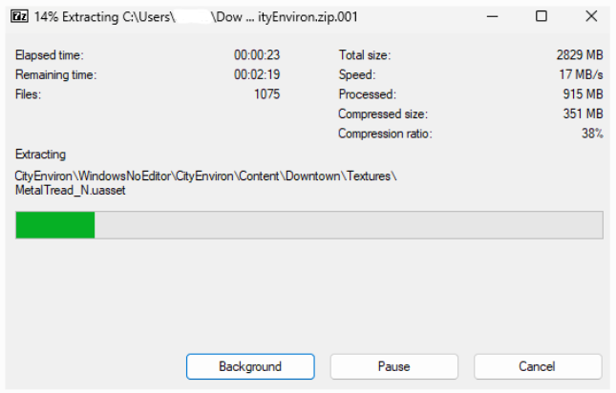

Once the extraction is done, you should get a new folder called “CityEnviron”. This is the result of combining the two files, so please open this folder.

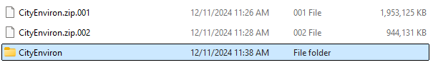

You will find that there are multiple layers of folders, but please navigate until you find a folder called “WindowsNoEditor”. This is the folder that contains all of the stuff we want, so I would recommend you right-click it and select “Pin to Quick Access”.




Once you have this folder pinned, please open it. You should see the following files. The application named “CityEnviron” should have an Unreal Engine logo, signaling that your installation of Unreal Engine version 4.27.2 was successful. If you do not see the Unreal logo, please check to see if you can run using Unreal Engine. If you cannot, redownload Unreal Engine version 4.27.2 and see if that works.

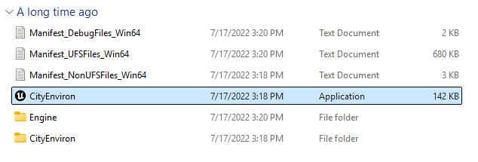

This CityEnviron application is the Airsim environment we are going to be using, so double-click to start it up. If it asks for permission to run, please permit it. It may take a moment to load, so please be patient.

Once you have the environment up, you should see a menu named “Choose Vehicle”. We are going to be working with the quadrotor simulation, so please pick the “No” option.

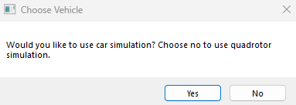

Once the environment opens up, you should see a screen that looks like this. DO NOT WORRY IF YOU CANNOT MOVE, we have not set up controls yet. This simulation is built to use an Xbox controller, but it is far easier to use keyboard controls which we will set up in the next lab section.

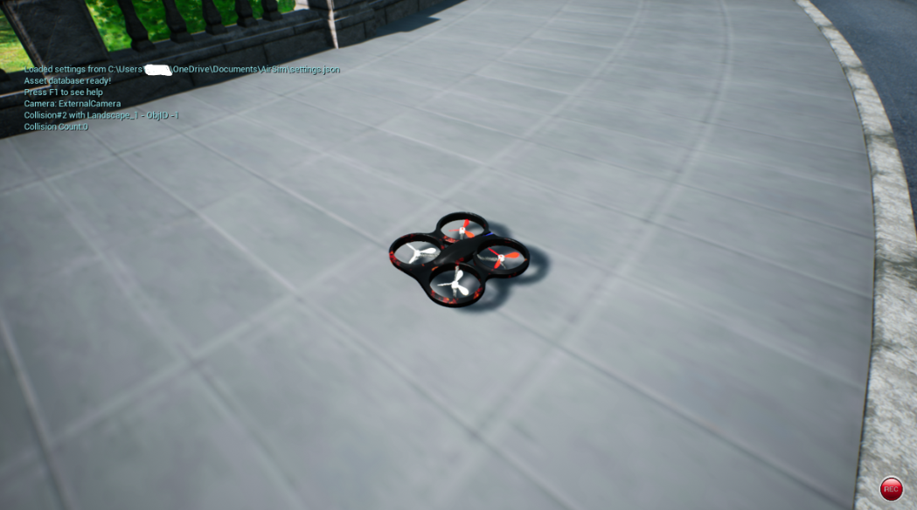

Submission details

You may now complete questions 1-4 on the Lab S05 quiz document. After you have completed these questions, you can move onto part B!

Conclusion

In this lab, we were able to successfully setup both our Unreal Engine and Airsim environment. Now that we have done both of these steps, it is time to move onto Part B where we will be setting up Virtual Studio Code so we can use the Airsim environment.

